CARD 2
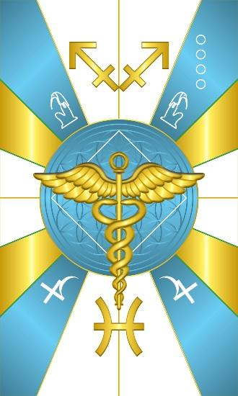
Card 2 represents the energy of Orunmila and Tehuti. Orunmila’s colors are Green & Yellow. Tehuti’s colors are light blue and white, so we have green lines outlining the Yellow/Gold color, & mainly Blue & White in the image. There are 16 angles radiating from the circle corresponding to the 16 major odu, which is a theme for all the cards.

In the upper quadrants we have the hieroglyphic determinative for Tehuti, the ibis headed God of Wisdom. In the lower quadrants we have the astrological glyph for the planet Jupiter. At the top we have the symbol for the constellation of Sagittarius and at the bottom Pisces, which are both signs ruled by Jupiter. Card 2 shares a relationship with Card 4 in that they both correspond to Jupiter. The sacred number of Tehuti is 2. Orunmila’s sacred number are 2 & 16. So we have 16 angles radiating from the circle to represent the connection to 16. We have a white square as the geometric symbol that is a harmonic of both 2 & 16. In the middle is the staff of Tehuti, which later became the rod of Hermes, then used as the Rod of Asclepius. It is also known as the Caduceus, and is a symbol of Wisdom and Spiritual Enlightenment. The snakes represent the kundalini rising.

Comments by Baba Awodele

